Guidelines on How to Format a Contribution to the PMMT 2012 Conference Proceedings
Gow-Yi Tzou¹, Wen-Tung Chien²
¹ Department of Mechanical & Automation Engineering, Kao-Yuan University
² Department of Mechanical Engineering, Ping-Tung University of Science & Technology
NSC Project No.：NSC95-2221-E-244-027-MY3

Abstract (11 points, Times New Roman, Boldface, Center)
In order to get a homogeneous look for all the papers to be published in the proceedings of the 2012Conference on Precision Machinery and Manufacturing Technology (PMMT 2012) held in Howard Beach Resort-Kending, Ping-Tung by Department of Mechanical and Automation Engineering, Kao-Yuan University, from May 18 to May 20, 2012, a set of guidelines for preparing these papers are given.
(Abstract content 10 points, Times New Roman)
Keywords：Proceedings, Guidelines, PMMT
(2～4 Words,10 points, Times New Roman)

1. Introduction
All papers are limited to no more than 10 (ten) pages, but at least 6 pages Authors should adhere to these guidelines wherever possible and only modify suggested formats if this helps in accommodating a certain figure, table etc. It could, for example, be of advantage to collect all figures and tables on the final page (as demonstrated in this template). It is of course equally acceptable to include the figures in the running text. The finalized manuscript should be submitted PDF and word file via the PMMT 2011 web-page.

2. Format

2.1 Paper format

2.1.1 Margin setting
The paper size is A4 (21 cm wide by 29.7 cm tall) with the following margins: upper 3 cm, lower 3 cm, left 2 cm, right 2 cm. These margin settings must not be altered under any circumstances!

2.1.2 Font setting
The only fonts that should be used are: Times New Roman and Symbol. Please pay in particular attention to avoiding other fonts with non-Latin characters. The title is in capitals, 14 point, boldface, the authors and their affiliations 12 points. The subtitles in the text are 11 point, boldface. The rests of the text are 10 point.

2.1.3 Line space setting
Line space is fixed to 12 point. Figures, tables and equations are edited by a single space.

2.2 Keywords
A list of up to 2-4 keywords should be included right after the abstract.

3. Figures, tables, and equations

3.1 Figures and tables
Figure (and table) captions should be written in 10 points, Times New Roman. Captions can either be centered or fully justified, depending on the width of the figure.

3.2 Equations
Equations should be centered and labeled with a number towards the right margin, in case there is more than one equation.

(1)

4. References
References are identified by a number in brackets and should follow the format as seen in the examples below for journal paper [1], book [2], conference paper [3], thesis [4], technical report [5], patent [6], and website [7].

5. Conclusions
We hope that you found these instructions helpful. We are looking forward to receiving your contributions. If you have problems or questions, please feel free to contact the following e-mail address:
fasteners@cc.kyu.edu.tw

6. Acknowledgment
Thanks to all those people helping in making PMMT 2011 very special events. Please add the sponsor project number if possible.

7. References
- C. H. Lin, G. B. Lee, Y. H. Lin, G. L. Chang, A Fast Prototyping Process for Fabrication of Microfluidic Systems on Soda-Lime Glass, J. Micromech. Microeng., Vol. 11, No. 6, pp. 726-732, 2001.
- B. Etkin, Dynamics of Atmospheric Flight, John Wiley and Sons, New York, USA, pp. 166-180, 1970.
- K. M. Shu and G. C. Tu, Metal Matrix Composite for EDM Grinding, Proceeding of the 13th International Symposium for Electro-machining, Spain, Vol. 2, pp. 869-879, 2001
- K. F. Hayes, Equilibrium, Spectroscopic, and Kinetic Studies of Ion Adsorption at the Oxide/Aqueous Interface, Ph.D. Dissertation, Department of Civil Engineering, Stanford University, Stanford, CA, 2001
- D. Strimatis, COMPLEX/PEM Air Quality Model User’s Guide, U. S. EPA, EPA-600/8/83-015, Research Triangle Park, NC, 1982
- C. W. Fitko and A. Ravve, Structure Analysis, U. S. Pat., 3374723, 1967
- website

8. Chart arrangement

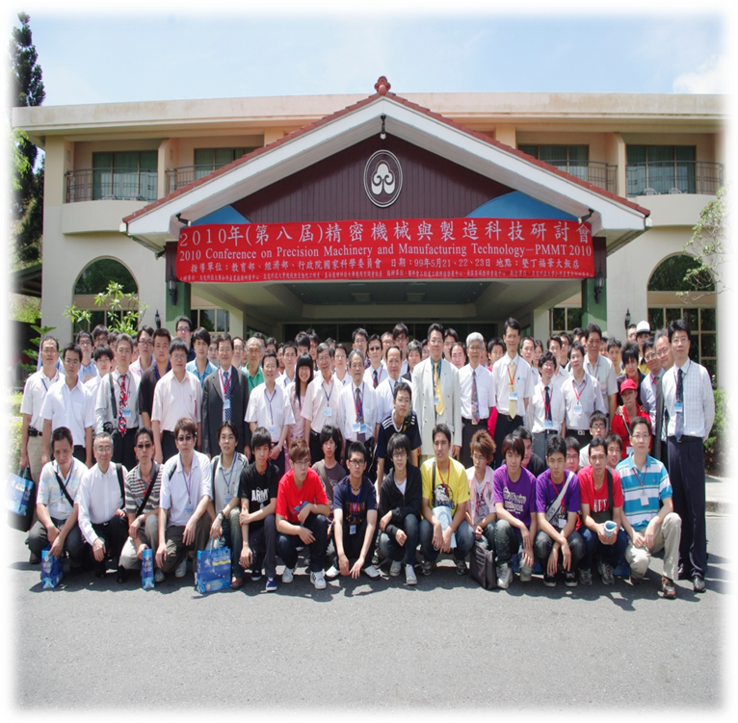
Fig.1 The PMMT 2012 was held in Howard Beach Resort-Kending, Ping-Tung from May 18 to May 20, 2012

Table 1 Important dates for the conference schedule
Deadline for submission | 2012.03.31
Notification of acceptance | 2012.04.18
Full paper due in final form | 2012.05.02

2012 精密機械與製造科技研討會論文格式摘要

鄒國益¹、簡文通²
¹高苑科大機械與自動化工程系
²屏東科技大學機械工程系
國科會計畫編號：NSC95-2221-E-244-027-MY3

摘要
高苑科大機械與自動化工程系假墾丁福華大飯店舉辦精密機械與製造科技研討會，活動日期自2012年5月18日至5月20日止，為了論文在收集及印刷過程中能有整齊的格式，故以本文做為準備論文時之準則。建議論文作者以本會提供之範本下載更改。

關鍵字 : 論文集、準則、精密機械與製造科技

